Tab 1



Thesis Proposal
CONSULTATION SHEET

Project Title:  Addressing Typographic Hallucination in Generative AI Images: An Open-Set Metric Learning Approach to Font Style Recognition | Week # 4 | Group Members:  - Janritch D. Diputado  - Matt Erron G. Cabarrubias
Date:
July 21, 2026
Progress Report (based on the adviser’s previous comments/suggestions) by Students
1st meeting (June 30):
- Justify why 50-100 fonts.
- Mention all fonts classified.
- Format as a 1-page file.
- Include General and specific objectives.
- Note that data is classified through Google.
- Justify commonly used fonts and narrow to just English.
Recommendations by Adviser
1st meeting (June 30):
Conceptual Framework:
- Remove "graphic designer".
- Enhance label details and readability.
- Relocate display results section.
Appendix: Add expert evaluation form.
- Define the maximum similarity score threshold.
- Establish protocol for handling low max similarity fonts and expert validation on unknown fonts.
Documentation: Include missing CVs.
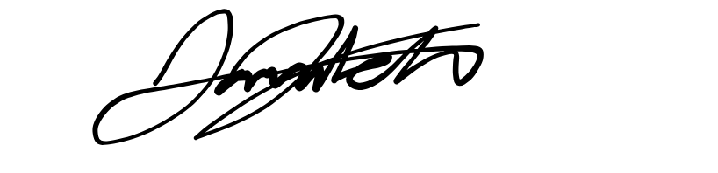
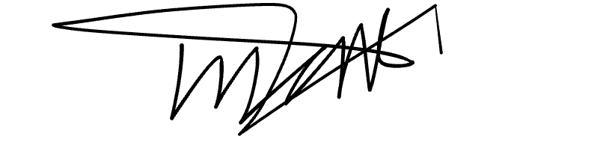
Prepared by:
Janritch D. Diputado | Matt Erron G. Cabarrubias
Noted by:
CHRISTINE D. BANDALAN, MEng
Thesis Adviser

Copy of Tab 1

Thesis Proposal
CONSULTATION SHEET

Project Title:  Addressing Typographic Hallucination in Generative AI Images: An Open-Set Metric Learning Approach to Font Style Recognition | Week # 4 | Group Members:  - Janritch D. Diputado  - Matt Erron G. Cabarrubias
Date:
July 21, 2026
Progress Report (based on the adviser’s previous comments/suggestions) by Students
1st meeting (June 30):
- Justify why 50-100 fonts.
- Mention all fonts classified.
- Format as a 1-page file.
- Include General and specific objectives.
- Note that data is classified through Google.
- Justify commonly used fonts and narrow to just English.
Recommendations by Adviser
1st meeting (June 30):
Conceptual Framework:
- Remove "graphic designer".
- Enhance label details and readability.
- Relocate display results section.
Appendix: Add expert evaluation form.
- Define the maximum similarity score threshold.
- Establish protocol for handling low max similarity fonts and expert validation on unknown fonts.
Documentation: Include missing CVs.

Prepared by:
Janritch D. Diputado | Matt Erron G. Cabarrubias
Noted by:
Christine D. Bandalan
Thesis Adviser

